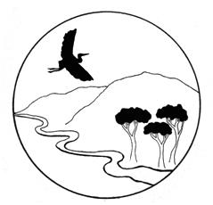

Russian River Property Owners Association

Officers: Brad Petersen, President; Paul Foppiano, Past President; Harry Black, Vice President; Rickie Pina, Treasurer; Carolyn Wasem, Secretary

MEETING AGENDA
Date: February 14, 2024
Time: 4:00 PM
Location: Fanucchi Ranch, 5155 Highway 128, Geyserville, CA
Join Zoom Meeting: https://sonomacounty.zoom.us/j/8117802240 Meeting ID: 811 780 2240
- CALL TO ORDER/ROLL CALL
- PUBLIC COMMENT (regarding items not on the agenda)
- APPROVAL OF MINUTES OF PREVIOUS MEETINGS – January 10, 2024
- CORRESPONDENCE
- FINANCIAL REPORT APPROVAL. Rickie Pina - January
- BOARD MEMBER UPDATES (For items not on the Agenda)
- COMMUNICATIONS UPDATE – GinaLisa Tamayo

- OTHER UPDATES (Refer to Handout for Additional Updates)

- ITEMS FOR CONSIDERATION:
Item 1. LAFCO District Formation (Chair Petersen)
- Review District Formation Budget
- Discussion to Proceed with LAFCO or Other Formation Avenue.

Item 2. Nomination of Officers/Board Members

Item 3. Annual Meeting, February 20th
- Topics/Speakers

- FUTURE AGENDA ITEMS
- NEXT MEETING – Annual Membership Meeting February 20th
Board Meeting March 13th
- ADJOURNMENT

